***Artificial respirator – Zephyros Project***

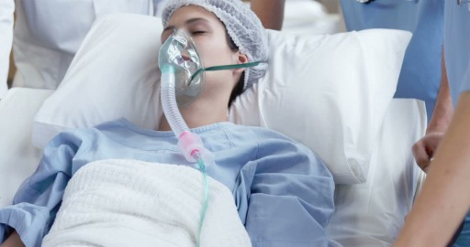

Team

Engineering

Abel Geovanny Loera – Linkedin – <https://www.linkedin.com/in/abel-geovanny-loera-navarro-a63542123>

Brandon F. Loera – Linkedin – <https://www.linkedin.com/in/brandon-f-loera-ba519ab7>

Medicine

María Jacqueline Martínez – [jacquelinemtz_84@Outlook.es](mailto:jacquelinemtz_84@Outlook.es)

Legal

Hannia Loera – Linkedin - <https://www.linkedin.com/in/hannia-melisa-loera-garcia-2a6779171>

Diffusion – Marketing – MedMark

Perla Elianne Garza – Linkedin – <https://www.linkedin.com/in/perla-elianne-garza-17361a15a>

Collaborators

Abel Loera – Linkedin – <https://www.linkedin.com/in/abel-loera-54841050>

Feliciano Loera – Linkedin – <https://www.linkedin.com/in/feliciano-loera-18232054>

Document control versions

|  |  |
| --- | --- |
| Version | Date |
| 1 | 27th March of 2020 |
| 2 | 29th March of 2020 |
| 3 | 1st April of 2020 |
| 4 | 3rd April of 2020 |
| 5 | 6thApril of 2020 |
|  |  |
|  |  |
|  |  |
|  |  |
|  |  |

Content

Introduction and scope 4

NOTICE 5

Conceptual diagram of the solution 6

Oxygen concentrator 7

Conceptual design 8

Process indication 10

Selection of the material 11

List of materials 14

Assembly 16

Absorbent preparation 16

Process 17

Process 19

Conclusion oxygen concentrator 20

Mechanical-electrical respirator 21

Mechanical-Electrical 22

Mechanical respirator 22

Electronic 24

Rest of the components 25

Control system 26

Control system conclusion 29

Monitoring visualization 30

Mask for partial breathing 31

Medical Operation Guide – Partial breathing substitution 32

Prototype costs 34

Oxygen concentrator 34

Mechanical-electrical respirator 34

Improvements 36

Conclusion 38

References 39

Annex 40

A. Mechanical ventilation 40

Introduction 40

Pulmonary ventilation physiology 40

Parameters that assess respiratory function 40

Clinical indications 41

Mechanical ventilation parameters 42

Basic and initial programming of the fan 42

Important – Complications of mechanical ventilation 44

Removal from mechanical ventilation – invasive total respiration only 45

B. Pressure Swing Adsorption (PSA) 46

Materials Specifications 46

C. Safety sheets catalog 48

D. Recommendations for the use of oxygen cylinders 49

E. Linear mechanical modeling during respiration 50

F. Multimedia 53

Introduction and scope

Currently the Covid-19 pandemic has become an "enemy of humanity"[1]according to the World Health Organization. Given this situation, we have seen that the main public health problem is in the number of artificial respirators and masks available [2].So we decided to work on finding a solution and develop a prototype that can be done by **personal and industrial approach.**

As part of the good practices to be able to solve a problem, we must first identify the main parameters to be controlled. With this in mind we made an investigation on this topic. See Annex A.

Based on our research, the factors to control are:

* Oxygen concentration.
* Total volume of air flow.
* Respiratory rate per minute.
* Oxygen pressure.

The first point involves a process of production of oxygen at a certain concentration and its regulation by valves; the last three points imply mechanical-electrical development.

On the other hand, to build the solution we must take seven main points in the design of the solution:

1. It must be built with common materials and access to industrial production lines.
2. Meet medical specifications.
3. Insurance.
4. It can be decontaminated, cleaned and reused.
5. Lower monetary cost compared to a common breathing system.
6. It's easy to build, maintain and upgrade.
7. Scalable in improvements.

With all the above in mind, we present you our proposal consisting of:

1. Oxygen concentrator.
2. Mechanical-electric respirator. (Design, motor, valves, Arduino and accessories, sensors and control system).
3. Mask.

Important:

The oxygen concentrator showed does not produce 99% concentrated oxygen and does not generate enough pressure to fill medical oxygen tanks. If you want to increase concentration and pressure you need more expensive materials and equipment. By using air filters, we removed much of the impurities in form of powder or particles suspended so the oxygen concentrated can be breathed without complications. The electric mechanical respirator can be printed with a 3-D printer or produced in parts at an industrial level by cutting material. The mask can be printed with a 3-D printer or you can create it by hand.

**This solution must only be used in mild to moderate cases when there is a partial substitution of the respiratory capacity, which means no intubation or entering systems to the trachea- lungs. The most severe cases require specialized machinery since sometimes there must be up to 99% oxygen concentration. For the replacement of the total respiratory capacity at the mechanical-electrical respirator level, we are working on a software update and new sensor connections-components to the Arduino, however, due to issues of time, budget and obtaining parts we have some delays.**

**This document is under continuous modification.**

NOTICE

              The creators, collaborators and associates involved in the elaboration of the artificial respirator presented in this document or any of its later versions and / or different language, are not responsible for the improper handling of the materials needed for their construction. In the event which individuals wish to replicate what has been seen in this document and/or all material related to the Zephyros project, it is the sole responsibility of the user that must follow correctly the steps presented within this document for the proper operation of the artificial respirator, otherwise the following harmful situations could be generated:

1. **Oxygen Concentrator:**Stand in a place at room temperature with good ventilation flow and otherwise you will ignore the tables presented in the attached document for selecting the best material to use, it may cause the following:
2. The oxygen concentrator will not be properly sealed, which would cause leaks, resulting in the possibility of suffocation due to oxygen displacement.
3. Failure to properly follow the instructions for the concentrator execution procedure will not guarantee the oxygen concentrations presented in this document.
4. **Respirator:**If not followed l a s specifications or steps established for the correct construction can generate:
5. Damage to the respirator and / or electronic system so it would not work properly.
6. That the respirator comes off and destroys generating accidents such as :
7. Damage to the health of the user or people around him.
8. **Mask:** The mask must be washed and free of soap at all times for its proper functioning.
9. **People who must create the artificial respirator:**Adults, therefore, do not leave it within the reach of children in order to avoid accidents.
10. **People who can use it:**Those adults who have mild, moderate respiratory difficulties, in both cases, who require partial respiratory assistance. Given the situation of a person with chronic and/or severe respiratory difficulties, please contact professionals for their appropriate treatment.

We are interested in your health and safety, so it is requested to follow the elaboration steps strictly, in this way you will have a good operation. That said, it must be taken into consideration and conscience that if you do not do so, you can see the user involved in one or more assumptions described above and not described , which, as we already mentioned, will not be our responsibility because it was effectively explained how to have good use of the product.

**Important:**For reasons of humanitarian crisis we allow the use of principles, designs, simulations, manuals, etc. for physical reproduction or improvement in any of its areas until the crisis by covid-19 ends, please contact us in case of improvements and possible agreements. Together we do more.

All documents and/or files and/or web pages and/or printed and/or electronic multimedia resources; whether design, simulation, manual, etc. And possible improvements themselves or by third parties that are related to the project Zephyros are considered as part of the project Zephyros thus are subject to reference all the names of the participants referred as "Team" within the project. We encourage the enforcement of copyright rights, intellectual property, brand, among others according to international treaties.

Conceptual diagram of the solution

Cloud

Monitoring

En

Oxygen concentrator

Orchestration

Note: The order of the sections “air compressor” and “water and CO2 elimination” inside the oxygen concentrator depends of the kind of compressor that you use.

Digital flow

Physical flow

Pressure regulation

Oxygenated air supply

Oxygen concentration regulation

Patient with non-invasive mask

Oxygen Accumulation

Water and CO2 elimination

Air compressor

Mechanical-electrical respirator

Sensibility Expiration

# Oxygen concentrator

Given the current pandemic, in our country (Mexico) it is very likely that certain localities will be left without a concentrated oxygen supply for their patients, so we decided to show a concentrated oxygen production process in the simplest possible way.

There are many procedures to obtain oxygen, however, in order to select a procedure we must take into account the following points:

* It must be built with common materials.
* It must be safe.
* Cheap.
* Simple to operate.
* Sufficient oxygen production.

Within these procedures we found two procedures as possible candidates to develop, the first is a process based on gas pressures and absorbent material (PSA) and the second based on electrolysis.

Electrolysis, without the appropriate materials, is costly at the electrical energy level, produces little oxygen and is quite unsafe since it generates gaseous hydrogen [3]and it is highly flammable and in appropriate conditions is explosive [4].

Therefore we select the pressure process called PSA.

Note: See Annex B for the theory behind the PSA.

## Conceptual design

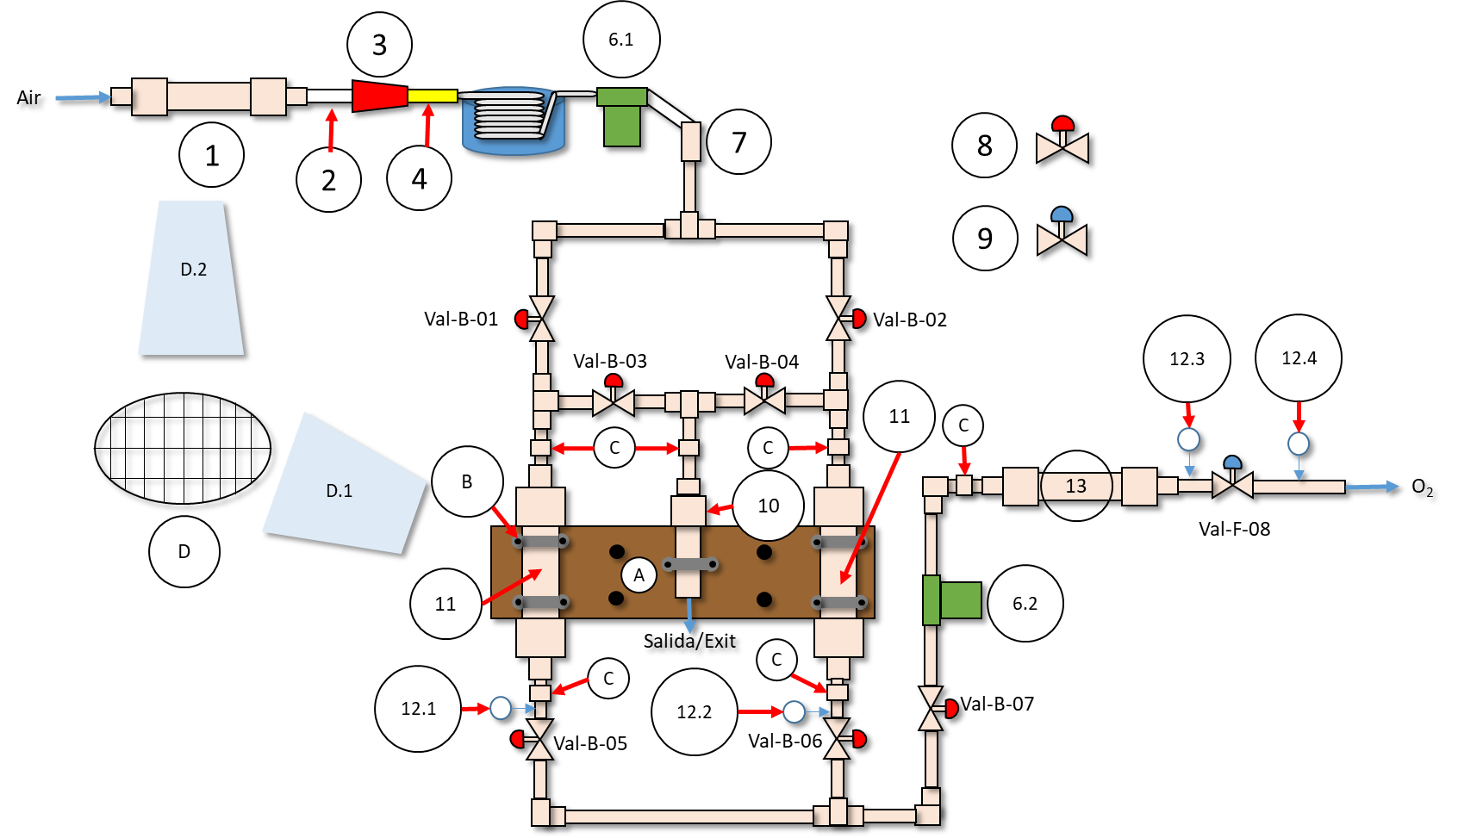

Where:

1. Eliminator of water (H2O) and carbon dioxide (CO2). 3 inches in diameter by 12 inches.
2. Transparent hose.
3. Compressor.
4. Compressor hose.
5. Coil and insulated container with lid filled with cold water. Minimum 5 revolutions.
6. Air filter.
7. Air filter-CPVC connector.
8. Ball valve (on- off) 1/2 inch.
9. 1/2 inch flow valve.
10. Purge system.
11. Absorbers.
12. Pressure gauges (manometers) of 150 psi, except for 12.4, which must be 100 psi.
13. Oxygen container. You can use a larger container than the one presented in this document but the pressure should not exceed 80 psi unless you use a professional oxygen cylinder and a compressor.

Adjuncts.

1. Wood or plywood board ½ inch thick.
2. Metal lugs/handles with screw, nut and washers.
3. Union nut. Allows the replacement of accessories in case of damage.
4. Steel mesh.

D.1 Two steel meshes per adsorbed. One upper and one lower.

D.2 Two steel meshes per water and carbon dioxide remover. One upper and one lower.

Notes: Name the valves, absorbers, etc; as seen in the diagram.

Mark valve positions when closed, this will help you for control and inspection during the process.

Depending on your type of compressor, it is likely that the water and carbon dioxide eliminator (1) and the compressor (3) change positions.

Whatever the case, these two parts must always be present continuously.

You can connect a compressor to the Val –F - 08 valve tubing outlet to compress oxygen and fill medical oxygen tanks.

## Process indication

According to the theory we will be working at pressures between 45 and 115 psi (4 to 8 bar) maximum. The air around us is at 14.7 psi, therefore we will be working with pressures higher than atmospheric.

It seems to be dangerous but the water you have in your house is between 40 and 80 psi maximum, so we will be working at relatively similar pressures but with gases [5].

Another factor to consider is the temperatures of the process and the environment around you, however, the temperature range of planet Earth on its surface ranges from -85 ° C (-117.4 ° F) to almost 60 ° C (140 ° F) [6].

And for the process, we will be working under the shade at a temperature similar to 25 ° C (77 ° F), however, the temperature of your home and region may be different from ours.

Note: See Annex C for the safety data sheets of the chemical products involved in the process.

Table 1. - Process production by type of absorber diameter. Oxygen produced between 60 - 80% concentrations with zeolite [7].

|  |  |  |  |  |  |  |
| --- | --- | --- | --- | --- | --- | --- |
| Selected Diameter (inch) | Length (inch) | Liters of oxygen / min | Kg of zeolite | Bucket or container of cold water (gallons) | Maximum tolerable pressure [1] (PSI) 40 | Maximum tolerable pressure [1] (PSI) 80 |
| 8 | 33 | 27.2 | 40 | 30.00 | 160.00 | 250.00 |
| 6 | 33 | 20.4 | 30 | 22.50 | 180.00 | 280.00 |
| 4 | 33 | 13.6 | twenty | 15.00 | 220.00 | 320.00 |
| 3 | 33 | 10.2 | fifteen | 11.25 | 260.00 | 370.00 |

Note: Table 1 shows the "selected diameter" column which is the diameter of the absorbers. The calculations are approximate theoretical.

The amount of liters of oxygen depends on the flow or flow of the compressor you use.

For a selected diameter of eight inches with that amount of liters of oxygen and a compressor 6 Hp compressed air flow 9 SCFM (262 L / min).

Important:

This process does not generate oxygen at high pressures (150 psi onwards).

A common oxygen tank has a pressure of approximately 600 psi and is made of industrial steel with ASTM standard specification [8].

Never leave the oxygen concentrator in the sun or near heat sources.

It should not be near the reach of children.

See Annex D for further indications on the proper use of oxygen.

## Selection of the material

To make the oxygen concentrator we selected CPVC since its maximum operating pressure [9]allows us to carry out the process, it is easy to find and it is less expensive than other materials. Regarding the environment, its absorption capacity of POPs pollutants is lower than other polymers such as: HDPE, LDPE and PP [10]which implies a significant reduction in pollutants accumulation inside the food chain once the materials are discarded and taken away as garbage, however, we strongly encourage a recycling attitude.

Another important point to mention about CPVC is its degradation.

Degradation can be mad by biological entities like fungi "Aspergillus fumigatus", "Phanerochaete chrysosporium", "Lentinus tigrinus", "Aspergillus niger" and "Aspergillus sydowii" which consume the CPVC [11] On the other hand, if CPVC is burned it will generate compounds like dioxins [12]which are harmful to the human body due to the chemical compound “vinyl chloride” which is a known carcinogen [13].

For all of the above, we recommend to use stainless steel if you have the appropriate budget.

Table 2. - Maximum pressure of the CPVC according to the internal diameter.

| **CPVC** | | | | |
| --- | --- | --- | --- | --- |
| **Diameter (inches)** | **External collapse pressure** ***(psi)*** | | **Maximum operating pressure** ***(psi)*** | |
| **Model 40** | **Model 80** | **Model 40** | **Model 80** |
| 1/2 | 1605 | 2006 | 590 | 850 |
| 3/4 | 1219 | 1740 | 480 | 690 |
| 1 | 948 | 1628 | 450 | 630 |
| 1 1/4 | 511 | 1399 | 365 | 520 |
| 1 1/2 | 366 | 1034 | 330 | 470 |
| two | 213 | 653 | 275 | 400 |
| 2 1/2 | 276 | 758 | 300 | 420 |
| 3 | 179 | 521 | 260 | 370 |
| 4 | 108 | 334 | 220 | 320 |
| 6 | 54 | 214 | 180 | 280 |
| 8 | 37 | 146 | 160 | 250 |
| 10 | 27 | 125 | 140 | 230 |
| 12 | 22 | 116 | 130 | 2. 3 |

However, it is also necessary to consider how does the temperature affects the material, in the case of CPVC it ​​is a thermoplastic, which means heat affects the pressure that the material can withstand and heat is closely related with temperature. Thus, the relationship between the pressure which the material can withstand and the temperature of the process/environment can be seen within the following table [14]:

Table 3. - Stratus factor according to temperature for different thermoplastics.

| **Stratus factor** | | | | | | | |
| --- | --- | --- | --- | --- | --- | --- | --- |
| **Temperature** | | **PVDF** | **CPVC** | **PVC** | **PB** | **PEX** | **PE** |
| ***( orC )*** | ***( orF )*** |
| twenty-one | 70 | 1.0 | 1.0 | 1.0 | 1.0 | 1.0 | 1.0 |
| 27 | 80 | 0.9 | 1.0 | 0.9 | 1.0 | 0.9 | 0.9 |
| 32 | 90 | 0.9 | 0.9 | 0.8 | 0.9 | 0.9 | 0.9 |
| 38 | 100 | 0.8 | 0.8 | 0.6 | 0.9 | 0.9 | 0.8 |
| 43 | 110 | 0.8 | 0.8 | 0.5 | 0.8 | 0.8 | 0.8 |
| 49 | 120 | 0.7 | 0.7 | 0.4 | 0.8 | 0.8 | 0.7 |
| 54 | 130 | 0.7 | 0.6 | 0.3 | 0.7 | 0.8 | 0.5 |
| 60 | 140 | 0.6 | 0.5 | 0.2 | 0.7 | 0.7 | 0.4 |
| 66 | 150 | 0.6 | 0.5 | 1) | 0.7 | 0.7 | 0.2 |
| 71 | 160 | 0.5 | 0.4 | 1) | 0.6 | 0.7 | 1) |
| 82 | 180 | 0.5 | 0.3 | 1) | 0.5 | 0.6 | 1) |
| 93 | 200 | 0.4 | 0.2 | 1) | 0.4 | 0.5 | 1) |
| 104 | 220 | 0.4 | 1) | 1) | 1) | 1) | 1) |
| 121 | 250 | 0.4 | 1) | 1) | 1) | 1) | 1) |
| 138 | 280 | 0.3 | 1) | 1) | 1) | 1) | 1) |

By using the values of table 3 you can calculate the maximum operating pressure based on the temperature of the place where you live.

For example, we selected 3-inch tubes for absorption, elimination of H2O- CO2,and pipeline which will function as an oxygen container, all or using the Model 80 CPVC; the maximum temperature of our region is 45 °C (113 °F), therefore the CPVC can withstand a maximum pressure of:

370 psi * 0. 8 = 296 psi

Therefore, we recommend that if you want to produce large amounts of oxygen using a larger diameter to 8 inches then change for another material such as stainless steel, this also means that you must change the valves, connecting tubes, elbows and T-type connectors, among other components.

## List of materials

1 air compressor.

It must be less or equal to 6 HP and with a flow capacity less or equal to 9 SCFM since this power and flow would be for a tube equal or greater than 8 inches in diameter. However, if you have a compressor with these characteristics then use it.

Optional: 1 refrigerator tank for the compressor.

CPVC. (Yellow color).

2 tubes. They can be of type 40 or 80. For both tubes, the same diameter. Use table 1.

1 tube 1 1/2 inch in diameter and 4 inches long. Purge / waste.

1 tube 3 inches in diameter and 12 inches long. Water and CO2.Eliminator.

1 tube 6 inches in diameter and 60 inches long. (Container for oxygen). Capacity of 27.8 L.

9 1/2 inch T-type connectors.

5 for pipe joints and 4 for manometers.

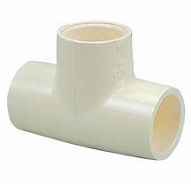 Way of union with the manometers -> 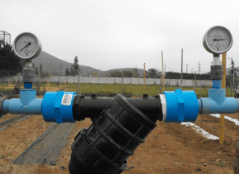

5 1/2 inch elbow connector.

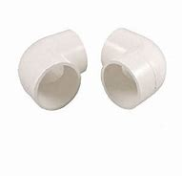

8 1/2 inch ball-type valves.

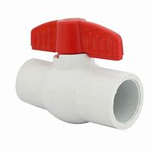

1 1/2 inch pressure regulating valve.

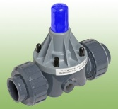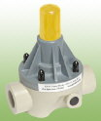

5 Nut-union.

Tube-cpvc male-female adapters.

3 meters tube 1 /2 inch in diameter to make connections.

Diameter reductors.

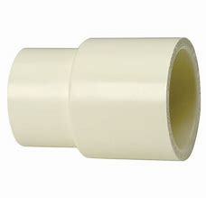

1 CPVC - Serpentine connector.

2 CPVC caps of the selected diameter for absorbers.

Bite union hose.

1 Teflon tape or paste.

3 manometers with measurement capacity up to 150 psi.

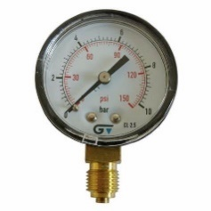

1 manometer with measurement capacity up to 30 psi.

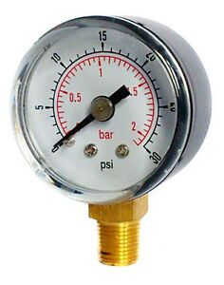

1 meter of transparent hose to connect to the compressor inlet (the diameter depends on your compressor)

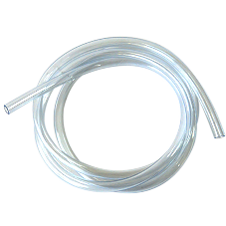

1 container for cold water and the size must be according to the diameter selected in table 1.

1 steel / aluminum serpentine.

1 bag of ice to cool.

4 round steel net that can be inserted into tubes with the selected diameter.

2 net round steel 3 inches

Note: Steel nets must have pores that are smaller in size than the absorbent to be used.

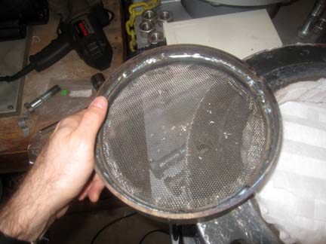

1 can of clear CPVC cement that allows pressures **between 180 and 250 psi.**



Cooler.

Absorbents.

CMS (Carbon Molecular Sieve), activated carbon or Zeolite type 5A (if any). The latter can be bought from silica producers or agriculture providers. See table 1 for the specific weight you need inside the absorber and to that amount add 5 kg of absorbent. If you're going to produce your own activated carbon then multiply that amount by 1.3. For more information regarding absorbents see annex B.

2 air filters between 4 and 0.01 microns.

## Assembly

Work below shade and in a ventilated place. Use the conceptual diagram to guide you through the design.

The tubes of the selected diameter and the H2O - CO2eliminator must have a lower net before ending step 8 inside section “Preparation of absorbents” and at the end of “Preparation of absorbents” you must add the other net.

Label the valves and other sections as in the conceptual diagram.

Clean each of the sections and parts very well before assembling it. The parts must be clean and dry.

Wash your hands continuously when you go to assemble the equipment.

Do not wash or get wet the absorbent, doing this could cause a decreasing effect in effectiveness.

## Absorbent preparation

IF you use CMS or specialized activated carbon for gas separation then go to step 6 of the procedure in this section else you will need to prepare your own adsorbent.

In our case we use zeolite, which is very common to use in aquariums. If you want to use activated carbon then see the procedure to follow in the following link: [https://www.wikihow.com/Make-Activated-Charcoal](https://translate.google.com/translate?hl=es&prev=_t&sl=es&tl=en&u=https://www.wikihow.com/Make-Activated-Charcoal)

For this we buy the necessary kg of zeolite according to the amount of oxygen we want to produce by a factor of 1.3 at the required weight (see table 1).

Materials.

* Absorbent.
* 1 Mortar with pylon (in Mexico you can use a molcajete) or ball mill.
* 1 steel container with lid (steel pot).
* 1 Gas stove or some heat source.
* 1 industrial mask with a 1 micron filter.

Process

1. Grind the absorbent by using the mortar and pylon until the size of the stones are less than half centimeter.

Note: In case you want to do this step with a ball mill you will need:

* 1 steel container with lid (can be a clean 1L can of paint)
* 40 1-inch steel pellets.
* Rotary motor.
* Support for the steel container and the motor.

Arrange the pieces as seen in the following image.

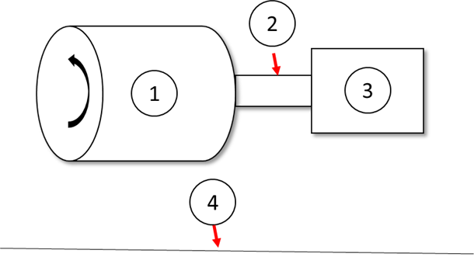

Image 1.- Homemade ball mill.

Where:

1. Steel container with lid.
2. Axis of rotation.
3. Motor
4. Floor of your house.

Process:

1.1. Fill the container without a lid to 1/3 of its capacity, evenly distributing the pellets and the absorbent.

1.2. Cover the container.

1.3. Activate the motor so that it begins to rotate until you are able to hear blows inside the container then you must maintain that speed.

1.4. Stop the motor every 5 minutes to inspect the size of the stone.

1.5. If the rocks are smaller than half a centimeter, the process ends, otherwise go back to step 1.4.

1. Separate the dust from the rock, there should be only rocks. For this you can use a mesh and move it laterally so all the dust going to the ground.
2. Put the rocks into the steel pot with dust-free lid.
3. Heat for at least half an hour at maximum power until you start seeing steam.
4. If after that minimum time you do not see steam, then turn off the stove and let it cool, you can use water to cool as long as the lid is tightly closed and only wet the exterior part of the steel pot.
5. Insert the rocks into the absorbers and cover them with the corresponding caps according to their CPVC diameter.
6. Repeat the procedure until the absorber 1, 2 and disposer of H2O - CO2are 90% capacity.
7. Put the upper net for each absorber.
8. Repeat steps 6, 7, and 8 for the H2O / CO2eliminator.
9. Bond all other missing sections with CPVC cement.

## Process

**Security procedure.**

Note: No pressure gauge should exceed 130 psi, if any exceed that pressure then the process must be aborted.

Follow these instructions for abortion scheme:

1. Turn off the compressor.
2. Close all valves.
3. Open Val-B-03, Val-B-01, Val-B-05 and Val-B-07 valves in that order for 100 seconds and at the end of that time the Val-B-03 valve must be closed.
4. Open Val-B-04, Val-B-06 and Val-B-02 valves for 100 seconds and at the end of time the valve Val-B-04 must be closed.

**Operating procedure**

1. Make sure that all valves are closed.
2. Make sure that pressure gauge 3 has a pressure lower than 80 psi, if it is greater than or equal to 80 psi, stop the process.
3. Open valve Val-B-01.
4. Turn on the compressor.
5. Observe gauge 1 and wait until the pressure is 100 psi.
6. When the pressure is 100 psi, close Val-B-01 and turn off the compressor.
7. Wait 120 seconds.
8. First open Val-B-07 and immediately afterwards Val-B-05 valve.
9. When pressure gauge 1 is 50 psi close valve Val-B-07 and Val-B-05.
10. If the pressure of pressure gauge 3 is equal to or greater than 80 psi, the process ends, otherwise continues.
11. Open valve Val-B-03.
12. Open valve Val-B-02.
13. Turn on the compressor.
14. Close Val-B-03 valve when pressure gauge 1 is 20 psi.
15. Observe gauge 2 and wait until the pressure is 100 psi.
16. When the pressure is 100 psi, close Val-B-02 and turn off the compressor.
17. Wait 120 seconds.
18. First open Val-B-07 and immediately after Val-B-06 valve.
19. When the pressure of manometer 2 is 50 psi, close valve Val-B-07 and Val-B-06.
20. Open valve Val-B-04.
21. Open valve Val-B-01
22. Turn on the compressor.
23. Close Val-B-04 valve when pressure gauge 2 is 20 psi.
24. If the pressure of pressure gauge 3 is greater than or equal to 80 psi, the process ends, otherwise it returns to point 5.

Important:

Constantly check the pressure on gauge 3. If the pressure is below 30 psi you will have to repeat the process.

If you use CMS then the oxygen will come out of the purge/waste section, therefore, you will have to adapt the process to follow.

Pressure losses through the pipe are minimal due to the size of the prototype.

You can automate the process using check valves, versa valves, etc. and connecting those with Arduino or you can automate it with pneumatic valves and timers.

The Val-F-08 valve and manometer 4 allow to control the concentrated oxygen flow and measure the necessary pressure towards the mechanical-electric respirator respectively.

### Conclusion oxygen concentrator

With all the aforementioned specifications and following each of these steps correctly you will have the ability to generate oxygen at a certain concentration in case of oxygen tanks shortage.

It is important to emphasize that the amount of oxygen produced depends on the air flow of your compressor since the filling times depend on it.

Do not work above the guidelines pressures, if you do, it will be at your own risk.

Seal each part very well to each other, if any part breaks, you can replace it using CPVC material.

You can increase the amount of production by creating more hubs.

If you want to produce large quantities of oxygen, you will need to change the material to steel tubes and you will need a change to other materials from CPVC to steel equivalent.

The support of the oxygen concentrator is essential, in this design a wooden support was used and screwed on the wall, however if you use steel you will have to adapt it.

Apply each of the safety instructions, for this read the safety sheets in annex C.

Also check all the recommendations of “handling concentrated oxygen containers”, please read Annex D.

# Mechanical-electrical respirator

The mechanical respirator consists of several sections:

* Mechanical-Electrical.
* Control system. See Annex E for further explanation of biomechanics and its control.

Conceptual design of the respirator without electronics:

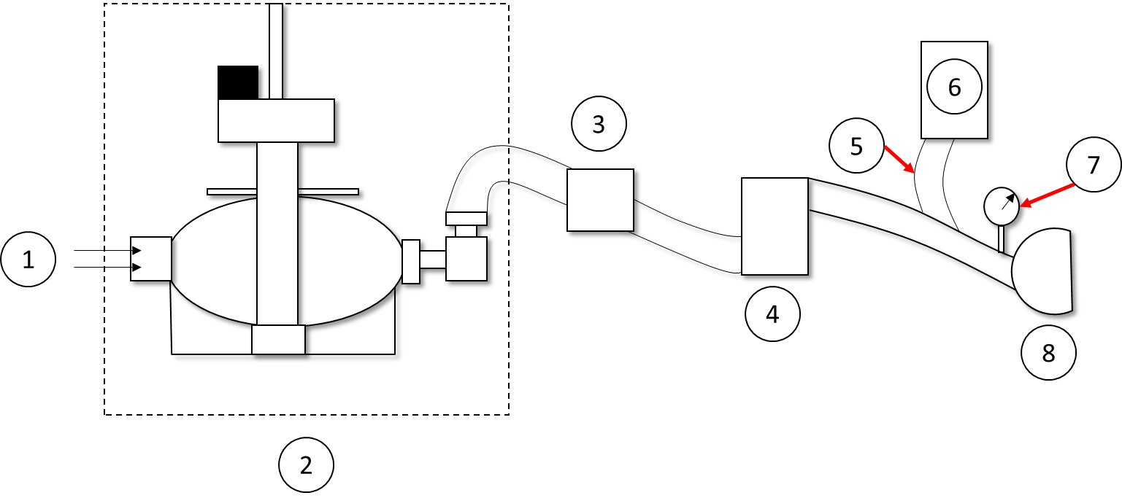

Where:

1. Concentrated oxygen and air input.
2. Electric mechanical respirator.
3. Pressure valve.
4. Humidifier with water based on patient weight.
5. Expiration output.
6. Humidifier for patient breathing.
7. Pressure gauge for negative pressure.
8. Mask.

## Mechanical-Electrical

The following respirator model allows three parameters to be regulated in a controlled manner during mechanical action.

* Total volume of air flow.
* Respiratory rate per minute.
* Pressure.

It also meets the following requirements:

1. It must be built with common materials and access to industrial production lines.
2. Meet medical specifications.
3. Insurance.
4. It can be decontaminated, cleaned and reused.
5. Lower monetary cost compared to a common breathing system.
6. It's easy to build, maintain and upgrade.
7. Scalable in improvements.

### Mechanical respirator

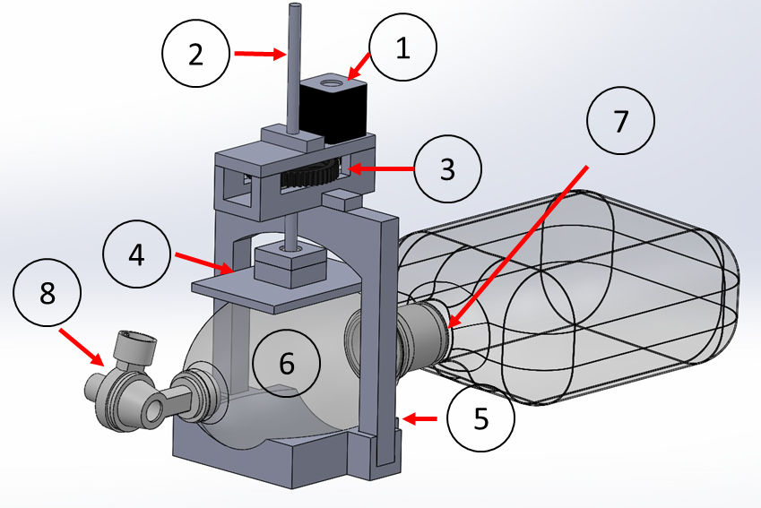

Figure 3. - Basic render design of the artificial respirator.

Where:

1. It is a "Nema 17" engine, widely used in 3-D printers, cheap and easy to get.
2. It is an axis made up of an endless screw with a big distance between each threaded shank. It allows the control of the pressure exerted and controls the air flow.
3. Gear system for mechanical work transfer between motor and worm gear.
4. Balloon flattening plate.
5. Skeleton and mechanism support. Avoid moving parts.

Manual respirator type “Ambu” (Airway Mask Bag Unit).

1. Balloon.
2. Air intake and concentrated oxygen entrance.
3. Connection to mask pipe with non-return valve.

Important:

Parts 6, 7 and 8 are glued together when buying it.

It can also be adapted to infants by replacing a smaller manual respirator and one of the flattening plate (4) by adapting the axis (2).

According to the literature, the oxygen flow at its maximum concentration when supplied to the AMBU ventilator represents a flow of 10 L per minute towards the entrance of the AMBU and presents the highest concentration points when you decrease the respiratory cycle from 1 minute to half a minute [16].

Since the highest volumetric flow of concentrated oxygen is 10 L per minute for the most extreme cases where the concentration is the highest possible indefinitely, if you have a 100 L tank you will be without oxygen in ten minutes while maintaining that flow.

According to the literature, between 15 and 20 minutes the patient will have to breathe oxygen at the highest concentration possible, after this point the oxygen flow will decrease until reaching fifty percent. The oxygen container presented in the oxygen concentrator has a capacity of 27.8 L. This means if the container is full you will have concentrated oxygen for less than 2.5 minutes when the flow is at its maximum.

When the pressure of the container equals the pressure of the environment the oxygen will stop flowing at the necessary pressure and it will not reach the machine.

It should be noted that the oxygen production capacity of the oxygen concentrator is always above 10 L per minute even using the smallest pipe in Table 1 but it depends on the compressor air flow.

See Annex D for recommendations and precautions regarding the use of medicinal oxygen.

Maintenance.

Since the parts of the section 1 respirator are assembled with screws, nuts and washers. The maintenance is quite simple. Technically unscrew, replace the part and re-screw.

### Electronic

Protoboard.

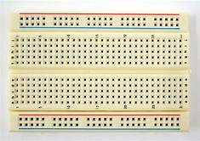

3.3V and 5V breadboard Power source or 12 V power supply and resistances.

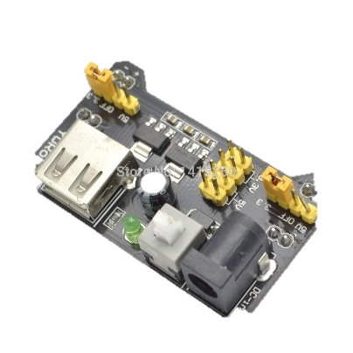

Arduino Mega.

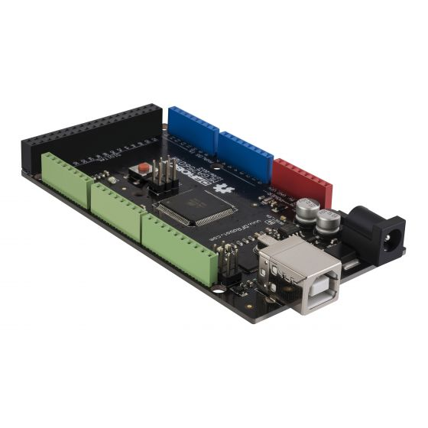

ESP8266 connection Wi-Fi.

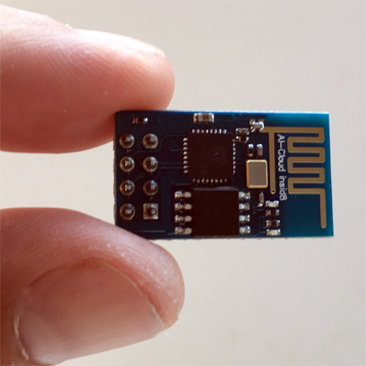

Driver A4988.

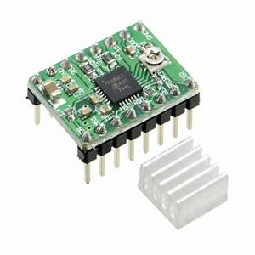

Nema 17.

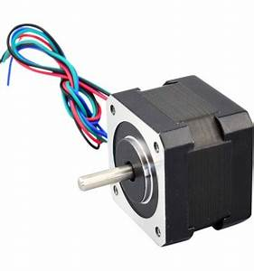

### Rest of the components

Acme screw.



Bearings.

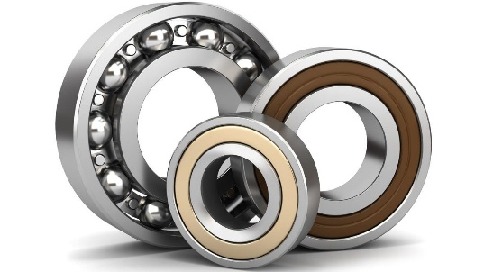

Nuts.

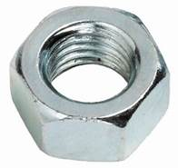

12V power supply.

Water containers and tubes.

Pressure gauge for negative and positive pressure.

### Control system

A control system regulates the outflow channel to the patient according medical indications and it is essential for the machine in order to operate in a semi-autonomous way.

The control system regulates the machine's concentrated oxygen air outlet valve, below you can see graphs of behavior within the control system used with a set of 2.5 cmH2O and 15 breaths per minute. However you can change settings for other conditions without affecting control. These graphs showed the behavior of the control system through simulation with “Altair Activate” © open source.

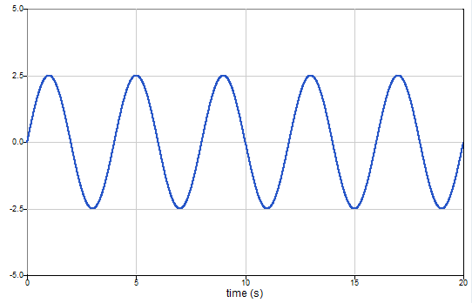

Figure 3. - Behavior of oxygen pressure at a pressure of 2.5 cm H2O and 15 breaths per minute (PaO2).

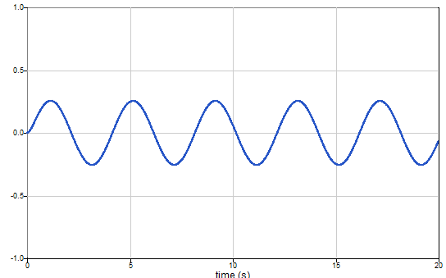

Figure 4. - Delivery air volume behavior (V or Tidal Volume).

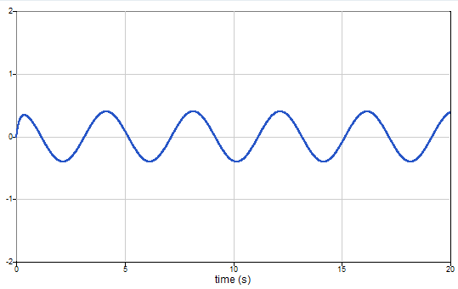

Figure 5. - Delivered volumetric flow behavior (Q).

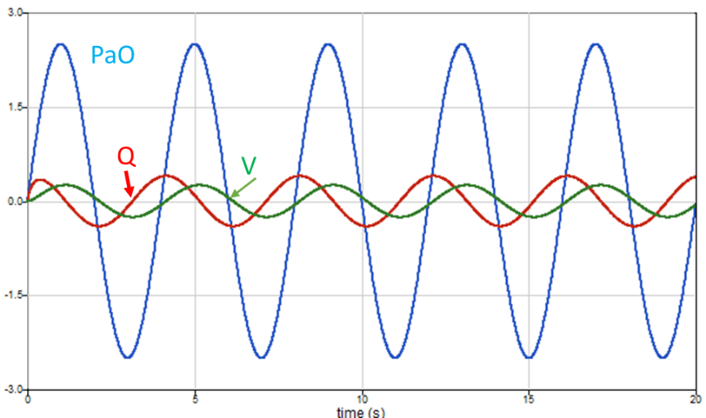

Figure 6. - Behavior of predictions for PaO2, Q y V.

These graphs showed the regulations of the concentrated oxygen pressure towards the patient, the volumetric flow of air and the Tidal volume to the patient for each breath. Following a sine pattern which, according to Annex A Table 4, is the best flow type since it increases the inspiratory time and is the most similar to normal breathing.

Even with the transfer function proposed in annex E equation Eq. 6, we would have a convergence problem after the 200 iterations, for this we insert a memory block to the system. This memory block only adds a delay of 1 integration per step-time to the circuit. It should be noted that this arrangement with the memory block, under certain circumstances, could incur numerical instability.

### Control system conclusion

We have a device that can provide concentrated oxygen at a certain respiratory frequency for non-invasive cases that complies with the literature [15].

There should not be a big time gap between the control system and its implementation since reaction time for the valves and the engine is pretty quick.

Furthermore, by solving the equation Eq. 1 and Eq. 2 of Annex E, you could estimate the pressure of the alveolus and the air flow that the pulmonary alveolus would receive. This will be very useful for a total breathing system.

Finally, this control system is insufficient to regulate total respiration. In order to accomplish this we need different sensors and a new control system.

Some of the main parameters to measure and regulate for total respiration are:

* CO2concentration.
* Extraction of H2O as vapor product of respiration.
* Frequency and respiratory force given by the brain to the lungs.
* Maximum pressure that an alveolus can support.

We are working to solve the problem of total respiration in a future software update through an update for control system and a procedure manual which will deliver all the connections from the new sensors and valves to the arduino without modifying the basic machinery and principles showed, however, we lack the budget, parts and time outside of working hours to be able to continue beyond the theory since they require medical tests in real time.

### Monitoring visualization

One of the most important but not critical point in a respirator is viewing machine and patient statement.

In our prototype design we decided that the use of monitoring screens per device is quite expensive and not scalable, therefore, we decided to migrate to the cloud with the idea of:

* Any device connected to the internet with a physical screen, projectors, holograms, etc. it is a potential monitoring screen.

Therefore, we created a monitoring board in the cloud so that it can be accessed by the staff in charge of patients in order to better control each patient and a maintenance monitoring board for technical staff.

If any of the devices fails, then it would be an indication of failure on both boards and cause the taking of actions, even though the respirator has an audible alarm.

However, it is important to emphasize that in our prototype is not 100% online at the moment.

Cloud conceptual diagram:

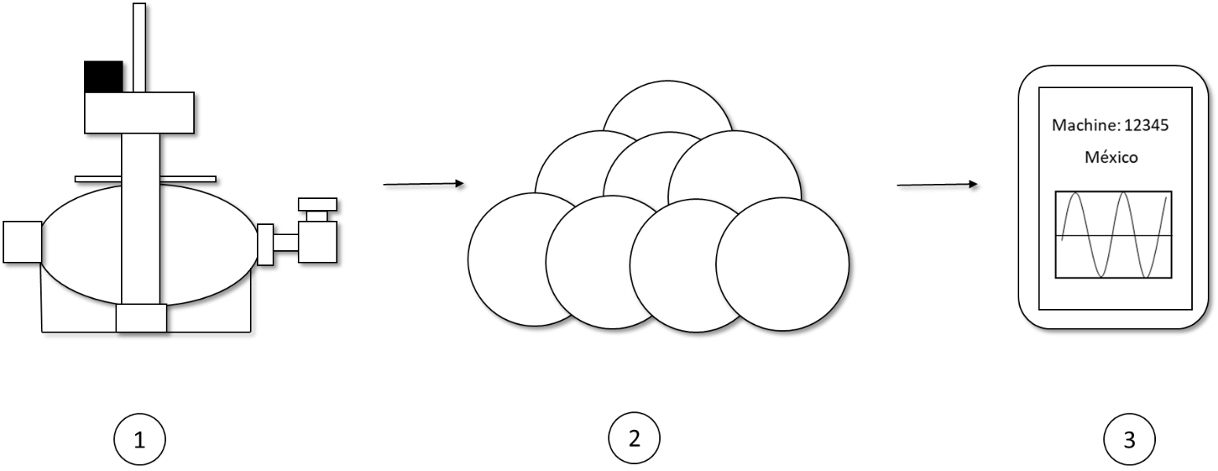

Where:

1. Mechanical-electrical respirator and sensors.
2. Cloud platform to support a large number of connected respirators.
3. Visualization on phone, laptop, tablet, etc.

Projected improvements to the platform and digitalization:

* Setting almost 100% online channel by developing improvements in the platform within the cloud to allow almost real time synchronization.
* Analytical to review potential improvements in the control systems so that it can later be implemented in the respirators automatically through an internet connection.
* Internet updates.
* Mobile app.
* Notifications system through mobile application.

## Mask for partial breathing

The mask is essential in an assisted breathing system. There are invasive and non-invasive. The difference lies in entering external devices into the body and in the case of total assisted respiration an invasive system such as intubation must be required.

In this project we are seeing a non-invasive type mask.

The most common mask model is as follows:

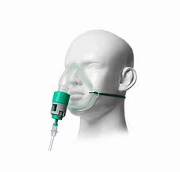

You can create it using PET bottles and garter.

Materials:

* Scissors.
* PET bottle 1 L or higher.
* Plastic hose.
* Garters.
* Scotch tape.
* Plastic cable ties.

Process:

1. Wash hands, scissors, hoses, rubber bands, and the bottle with soap and water without leaving soap traces.
2. Use a 1 liter or larger PET bottle.
3. Cut the bottle as the image marks:

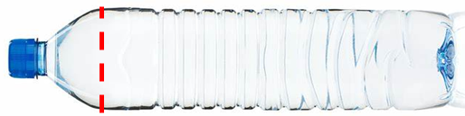

Note: Make a slight bend so it can fit your nose smoothly.

We will use the part of the mouthpiece to take, we will call it "upper part".

1. Insert garters to the sides of the top.
2. Use the tape to cover the cut edges with the scissors to avoid discomfort.
3. Remove the top cover.
4. Wash with soap and water.
5. Dry the top very well.
6. Connect the hose to the nozzle.
7. Seal the hose and the nozzle using tape - garters-plastic cable ties.

With this you will have your own mask. Adjust it very well avoiding gas leaks.

Remember to wash the mask in case it is going to be used by someone else.

## Medical Operation Guide – Partial breathing substitution

Important: This is only an operation guide, it does not imply the substitution of a health professional.

Before you start, make sure you have oxygen on hand, a stopwatch or alarm phone, print out the procedures for making oxygen, and have the printed guide. You should also read Annex A in its entirety.

You must have everything connected and ready including the oxygen tank or concentrator connected to the mechanical-electric respirator.

Remember that the total volume of your oxygen container defines the number of minutes according to the flow to be used in the "procedure" section. If your tank is 100L then divide 100 by the supplied oxygen flow and it will be the maximum minutes of available oxygen.

If you could not automate the process of the oxygen concentrator or do not have enough oxygen cylinders, will n to take turns and guards among several person as to assist those affected and execute procedures.

If the affected person has any previous or chronic illness, please contact a health professional first.

Process

1. Lay the affected person down in a comfortable place with a shape as semi fowler.

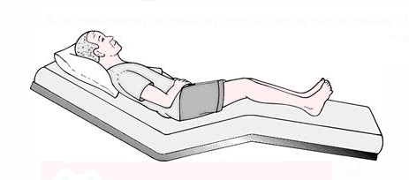

1. Turn on the electrical mechanical respirator and set it to run at 15 breaths per minute.
2. Set the respirator to a constant flow of 10 L per minute.
3. Fill the two containers with water, the first must have 4 ml per Kg of mass and is connected between the systems so it humidify the air to the affected person. The second is at the end of the tube for expiration, the tube must be hitting the water.
4. Schedule alarms on your cell from 1 minute to complete 20 minutes, set 5 minute alarms after the first 20 minutes for the next 45 minutes and then keep those alarms indefinitely.
5. Put the mask on the affected person. It should be tight, not tight.
6. Verify that the mask has no outdoor sections and is glued to the face.
7. Ask the affected person how they feel about the mask. Does it bother you? Where?
8. Activate alarms.
9. Opening the oxygen valve connected to the cylinder of oxygen or concentrate r oxygen with a flow rate of 10 L / minute.
10. Constantly check the pressure of the oxygen cylinder or oxygen concentrator.
11. When the pressure is less than 35 psi, run the procedure for generating oxygen in the oxygen concentrator or prepare the next cylinder at your disposal.
12. Repeat steps 11 and 12 for until the last 20-minute alarm ends.
13. Regulates the respirator flow to 8 L per minute and the oxygen flow to 8 L per minute.
14. Every 15 minutes you will reduce 1 L per minute with respect to your last flow until you are at 5 L per minute.
15. Constantly check the condition of the mechanical-electrical respirator and the oxygen pressure in your oxygen cylinder or concentrator. If you built the oxygen container in this document, when you reach 5 L per minute you will have oxygen for five minutes.
16. Set alarms continuously and keep an eye on the affected.
17. Wait for the affected person to recover, follow the instructions of the health doctors, if it worsens, please call the emergency numbers of your country and region.

In Jalisco, México: +523338233220

## Prototype costs

Note: The costs are only for material, we do not include costs for labor. As of April 2, 2020. The cloud platform is on our side. The cost of the mask is not included since it is handmade.

### Oxygen concentrator

|  |  |
| --- | --- |
| Equipment/Material | (USD) |
| CPVC Tubes | 25 |
| T type connectors x 9 | 5 |
| Elbow type connectors x 5 | 5 |
| Diameter reductors | 10 |
| CPVC Caps x 2 | 2 |
| Teflon tape | 2 |
| Ball valves x 8 | 10 |
| Threaded valve x 1 | 15 |
| Manometer x 4 | 45 |
| Union nut x 5 | 5 |
| Tube-cpvc male-female adapters | 3 |
| Compressor | 80 |
| Wood panel | 3 |
| Lug/Handles x 4 | 10 |
| Cooler | 2 |
| absorbent (depends on the size) 25 kg | 6 |
| Steel nets x 6 | 36 |
| Cement x 1 can | 3 |
| Transparent hose x meter | 1 |
| Filters (sheet) m2 | 5 |
|  |  |
| Total | 283 |

### Mechanical-electrical respirator

|  |  |
| --- | --- |
| Equipment/Material | (USD) |
| SMC | 120 |
| Arduino Mega | 20 |
| Wifi Module | 8 |
| Driver A4988 | 1.5 |
| 12V power supply | 10 |
| Nema 17 stepper motor | 9.2 |
| 3/8" screw stud | 25 |
| 3/8" bearings | 3 |
| 3/8" nuts | 3 |
| M4 screws | 3 |
| AMBU | 26 |
| 3-D printing | 11 |
| Protoboard | 4 |
|  |  |
| Total | 238.7 |

These costs to the product will decrease in environments of industrial production lines. In addition, only the presented mechanical-electric respirator is at least twice cheaper than the cheapest model of fans for this item in industrial production, and the fan shown online does not include an oxygen generation capacity or allow working under the appropriate conditions. For air-assisted breathing with concentrated oxygen, however it is smaller the cheapest model.

[https://m.alibaba.com/amp/product/60776944726.html](https://translate.google.com/translate?hl=es&prev=_t&sl=es&tl=en&u=https://m.alibaba.com/amp/product/60776944726.html)

## Improvements

As part of any project we are continually improving.

We have decided to include the main improvements in process that we are making.

Adaptability for other compression systems, an example would be the compressible accordion type container, among others.

Conceptual example:

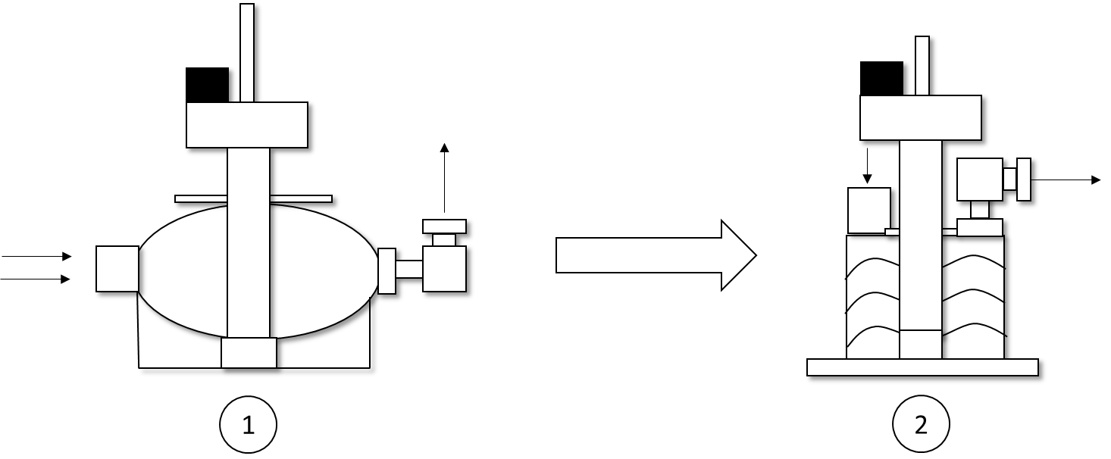

Where:

1. Mechanical-electric respirator presented.
2. Adaptation to accordion type respirator.

Oxygen concentrator.

* Automation of the oxygen generation process and emergency process.
* Increase in the concentration of oxygen generated during the process.

Mechanical-electric respirator

* System capable of adaptation in case of replacement of the AMBU respirator.
* System with capacity of adaptation for infants.
* Cover the replacement of total breathing for the patient.
  + Improvements in the control system for total breathing.
  + Incorporation of new sensors.
  + Technical manual for the implementation of physical components-connection.
* Updating of software-control system via internet.

Mask

* Include other models of mask for 3-D craft printing.

Medical operation

* Include manual of medical operation for invasive cases.

Strengthen cloud platform.

* + Online channel with the machine.
  + Robust access security system.
  + Include patient sensors.
  + Improved dashboard for patients / technicians.
  + Analytics.
    - Improvement in the control system control cycle.
    - Patient regulation.

Improvements in long-term vision.

Mobile app.

Oxygen concentrator

* Physical reduction of the oxygen generation process.
* Change of materials for the oxygen generation process.

Complete Solution

* Machine operation configuration from portable devices.
* Smart system.
* Data Lake.

## Conclusion

With all these investigations, iterative calculations and constant design modifications, we obtained a first prototype of a partial artificial respirator that:

|  |  |  |  |
| --- | --- | --- | --- |
| Point | To consider | Status | Comments |
| 1 | It must be built with common materials and access to industrial production lines. | Done | Electrical control devices are easily accessible for production lines. |
| 2 | Comply with medical specifications. | Done | Concentrated oxygen free of impurities through filters.  Control system for respiratory regulation and medical parameters.  System with manual configuration capacity.  Sensitivity to expiration. |
| 3 | insurance | Done | As long as it is in a box and out of the reach of children. Non-toxic materials. |
| 4 | Can be decontaminated, cleaned and reused | Done | Being segmented, it allows quick disarmament. |
| 5 | Lower monetary cost compared to a common breathing system. | Done |  |
| 6 | Simple to build, maintain and upgrade. | Done | Few parts, segmented and easy to replace. Update online. |
| 7 | Scalable in improvements. | Done | Module-based design with quick installation and adaptation. |

This solution is made up by:

1. Oxygen concentrator.
2. Mechanical-electric respirator. (Design, motor, valves, arduino and accessories, sensors and control system).
3. Mask.

We also include a user manual and include annexes to support what is presented in this development.

Document subject to modifications and updates.

## References

[1] <https://www.msn.com/en-in/finance/news/who-chief-says-covid-19-enemy-against-humanity-as-global-cases-top-200000/ar-BB11nXqI>

[2] <https://www.nytimes.com/2020/02/29/health/coronavirus-preparation-united-states.html>

[3] <http://www.hydrogencarsnow.com/index.php/hydrogen-from-water/>

[4] <https://www.sciencedirect.com/science/article/pii/B978012812036100007X>

[5] <https://www.familyhandyman.com/plumbing/boost-low-water-pressure-in-your-house/>

[6] <http://earthguide.ucsd.edu/eoc/special_topics/teach/sp_climate_change/p_planet_temp.html>

[7] <https://www.ijser.org/researchpaper/Oxygen-Separation-from-Air-Using-Zeolite-Type-5A.pdf>

[8] <https://healthfully.com/o2-cylinder-hydrostatic-test-requirements-7482823.html> ; <https://www.astm.org/Standards/G175.htm>

[9] <https://www.engineeringtoolbox.com/cpvc-pipes-pressures-d_240.html>

[10] [https://web.archive.org/web/20140907211639/http://www.algalita.org/blog/?p=3740](https://web.archive.org/web/20140907211639/http:/www.algalita.org/blog/?p=3740)

[11] Ishtiaq Ali, Muhammad (2011). Microbial degradation of polyvinyl chloride plastics (PDF) (PhD). Quaid-i-Azam University. pp. 45–46 & 122.

[12] Costner, Pat (2005) "Estimating Releases and Prioritizing Sources in the Context of the Stockholm Convention" Archived 27 September 2007 at the Wayback Machine, International POPs Elimination Network, Mexico.

[13] International Agency for Research on Cancer (IARC). "Vinyl chloride, polyvinyl chloride, and vinyl chloride-vinyl acetate copolymers." Vol 19, 1979. IARC. "Vinyl chloride." Supplement 7, 1987. Lyon.

[14] <https://www.engineeringtoolbox.com/thermoplastic-pipes-temperature-strength-d_794.html>

[15] Michael C.K. Khoo. Physiological Control Systems: Analysis, Simulation, and Estimation, segunda edición. The Institute of Electrical and Electronics Engineers, Inc. Publicado en 2018 por John Wiley & Sons, Inc. pp 31-61.

[16] <https://pubmed.ncbi.nlm.nih.gov/16053945/>

# Annex

## Mechanical ventilation

### Introduction

Mechanical ventilation is a resource of medical therapy used to give life support whose objective is to support or replace respiratory function until the total or partial reversal of the underlying problem that caused respiratory failure.

The knowledge and understanding of physiological and pathophysiological processes together with the constant improvement of mechanical ventilators based on technological advances have improved the survival of patients in critical condition.

### Pulmonary ventilation physiology

The lungs are elastic structures with resistance to volume expansion. Under normal conditions, the lung contains air inside it by positive pressure and external negative pressure in the pleural space.

Under normal conditions, the lungs adjust to the chest walls. There is a volume level at which the lung tendency to contract and the tendency of the chest wall to expand are the same, this being the resting position of the respiratory system. This is known as "Residual Functional Capacity" (CFR).

During inspiration (inhalation), muscular force overcomes lung and rib cage retraction, however, as the lungs fill with air, there comes a point where the elastic and muscular retraction forces equalize, making it impossible to incorporate more volume. To airspace. This phenomenon is known as "total lung capacity" (CPT).

Expiration (exhaling) is a passive process induced by the elastic force of pulmonary retraction that ranges from CPT to CFR. By continuing to expel air to levels below the CFR, a pulmonary contraction is carried out, however, an elastic counter-force of expansion is necessary to prevent lung collapse by equating said expansion force with the muscular force, the residual volume (VR) is obtained, this means the lung cannot expelled any more air.

### Parameters that assess respiratory function

See Image 1 along with the reading.

Two types of lung volumes are divided into static and dynamic.

Static lung volumes: They are the ones that measure the volume of gas in the different positions of the rib cage. There are four volumes and four capacities resulting from the sum of the previous ones

#### Volumes

Residual volume (VR): Volume contained in the lungs after a maximum expiration (approximately 1,200 ml).

Tidal volume (CV): Mobilized volume at rest (approximately 500ml).

Inspiratory Reserve Volume (VRI): volume that can be inspired after a normal inspiration (approximately 3,000ml = 3 L).

Expiratory reserve volume (VRE): Volume that can be exhaled after a normal exhalation (approximately 1 100ml = 1.1 L).

#### Capacities to consider for the machine

Total Lung Capacity (CPT): Volume of gas contained in the lungs at maximum inspiration (approximately 5,800 ml).

Vital Capacity (CV): Maximum exhaled gas volume one maximum inspiration (exhalation) (approximately 4,600 ml = 4.6 L).

Inspiratory capacity (IC): Maximum inspired volume (approximately 3,500ml = 3,500 L).

Functional residual capacity (CFR): Volume of gas contained in the lungs after normal expiration (2,300ml = 2.3 L).

#### Dynamic lung volumes

Forced Vital Capacity (CVF): Total volume exhaled through a maximum forced expiration.

Vef1 / Fev1: Volume of gas exhaled during the first second of exhalation.

FEF: Air flow in the middle part of expiration (between 25% and 75% of CVF).

FEV1 / CVF ratio: Known as the Tiffeneau index (it is considered pathological with a level below 0.7). In invasive breathing.

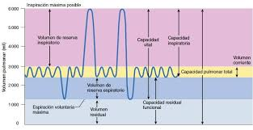Image 1. – Breathing curve per minute

### Clinical indications

1. Type I respiratory failure or severe hypoxemia: hypoxemia with normal or low PaCO2, increased alveolar-arterial O 2gradient (AaPO2> 20 mmHg). PaO2of less than 50 mmHg, decrease in arterial oxygen saturation and content, despite administering supplemental oxygen at a concentration equal to or greater than 50%, either through a venturi mask or a mask with a reservoir. It is the most common type of IR. To diagnose the above you need to do an arterial blood gas.
2. Respiratory failure II or hypercapnic: hypoxemia with elevated PaCO2and normal alveolar-arterial O2gradient (AaPO2 <20 mmHg), decrease in pH below 7.25, and the life of the patient is at risk. To diagnose you need to do an arterial blood gas.
3. Neuromuscular compromise of respiration: Demyelinating diseases or post traumatic injuries of the spinal cord or central nervous system.
4. Intracranial trauma: for initial management with controlled hyperventilation.
5. Hemodynamic instability: marked reduction in PvCO2, unstable blood pressure.

### Mechanical ventilation parameters

Table 1. - Parameters for mechanical ventilation.

|  |
| --- |
| Respiratory rate (FR): 12-16 breaths per minute  Tidal air volume (VT): 4ml O2/ kg or more (For each Kg of the patient's weight , if you do not have a scale, use table 3 )  Tidal volume (V): 5-10 liters / minute  Vital capacity (CV) 10-15 ml / kg minimum  Inspiratory negative pressure (PNI)  Minimum: -20cm H2O , Maximum: -30 cm H20  Minimum dynamic distensibility: 25ml / cm H2O (1758 ml = 1.7 L / psi)  FR / VT ratio should be less than (<) at 100 breaths per minute per liter.  Re consistency of the system <5cm H2O / L / sec (Minimum pressure for air with oxygen to flow into the lungs)  (0.35585 psi + atmospheric psi)) / L / second) |

### Basic and initial programming of the fan

Ventilator mode: It is the first parameter to be programmed. Must be started in controlled or assisted / controlled mode (Invasive only). The volume-controlled mode allows evaluating the patient's respiratory mechanics, reserving the pressure-controlled one for circumstances where there is a compromise of compliance or resistance.

FiO2: In most cases it will be started with an inspiratory fraction of oxygen of 100% for 15 to 20 minutes to seek to resolve any possible hypoxic situation. Subsequently, it will be regulated based on pulse oximetry, seeking that the patient's saturation level be at least 92%. It will decrease the FiO2at intervals of 10-20 minutes with changes of 10 percentage points hast to wear less than 50% of FiO2to avoid unwanted effects. An oximeter is required on hand.

Table 2. - Basic programming of the mechanical fan [5].

|  |
| --- |
| Ventilator mode         A / C, SIMV                Spontaneous                Volume or pressure  FiO2(Inspiratory Fraction of Oxygen - Oxygen Pressure) first 20 minutes.  Graduate with pulse oximetry (% blood oxygen).  Goal to carry 92% or more Goal less than 50%,  Breathing frequency,  12-16 breaths per minute  Peak flow, inspiratory time and I:E ratio.  Controls how fast the VT is delivered or how long the programmed inspiratory pressure is delivered  Flow wave pattern. See table 4.  Square, decelerated, sinusoidal |

Tidal Volume / Running Air Volume (VT): 6 - 8 cc (ml) of volume per kilogram of ideal weight will be programmed at the beginning. The ideal weight calculation will be made with the formula shown in Table 3 if the patient's weight is not known. The programmed volume should not exceed 35 cm of peak inspiratory negative pressure to avoid complications such as:

Barotrauma or volume-trauma. If this level is exceeded, the programmed tidal volume should be lowered to 4cc (ml) per kg of ideal weight.

Table 3. - Calculation of ideal weight (PI).

|  |
| --- |
| Man 50 + 0.91 [Height (cm) - 152.4]  Female 45 + 0.91 [Height (cm) - 152.4] |

Respiratory rate: will start with a respiratory rate of 12 - 16 breaths per minute. For the regularization of this parameter, the calculation of the minute volume (VM) that is given by the relation should be considered:

$$VM = FR x VT Eq. 1$$

Sensitivity: Control that programs the ventilator response regarding the patient's respiratory effort (vital capacity); it can be programmed by pressure (non-invasive) or by flow (invasive). The higher the programmed absolute value, the greater the effort on the part of the patient will have to reach the sensitivity level and could lead to exhaustion. When programmed by flow in positive liters / minute values, a flow is generated precisely in which it is available at all times for the patient, who only has to make a minimum effort to reach the flow level for the ventilator to recognize said effort and provides scheduled ventilator support.

Inspiratory Flow / Peak Flow: Controls the rate at which the tidal volume (of flowing air) (VT) is delivered or the time at which the programmed inspiratory pressure is applied, thus determining the inspiratory time (highest flow rate = less time to fulfill the programmed volume).

Flow wave pattern: Indicates the way in which the inspiratory flow is delivered, the inspiratory time, the tidal volume and the inspiration / expiration ratio (inhalation / exhalation) must be evaluated; three being the most frequently found in the fans described in Table 4.

Table 4. - Flow wave pattern.

|  |
| --- |
| a) Constant flow or square wave: it delivers the volume in less time but generates more pressure in the airway than the others.  b) Decreasing or descending ramp flow: it generates a higher airway pressure at the beginning and an almost equal alveolar pressure; it distributes the tidal volume better, also promotes a longer inspiratory time at the expense of expiratory time.  c) Sine flow: it distributes the flow similar to the previous one but increases the inspiratory time even more, some authors believe that it is the closest thing to the physiological one. |

Inspiratory Time and I: E Ratio: Inspiratory time is regulated taking into account how long it takes the patient to deliver the programmed volume or pressure. In addition, it should be noted that it is not too short to generate discomfort in the patient, nor too long that it hinders the time to expire and generates auto PEEP [2]as it cannot complete the exit of the gas supplied during inspiration.

The relationship between inspiration and exhalation or I:E. **Must be always a 1: 2 ratio**in such way that if we program FR at 20 per minute, we will have that inspiration will be in 1 second and expiration in 2 seconds, if we make changes in this I:E ratio we will also have to change the speed of flow since you must accomplish the inspiratory time as previously explained without problems in inspiration.

### Important – Complications of mechanical ventilation

The possible complications expected during the entire process involving assisted mechanical ventilation (from intubation to mechanical weaning) vary according to the phase in which the ventilation is, they are indicated below:

During intubation: Trauma, aspiration of gastric contents, arrhythmias

During mechanical ventilation: wrong position or obstruction of the tube, accidental leakage of the tube from the trachea

Posterior to remove the trachea tube: commitment airway reflexes and sequelae laryngeal - tracheal.

Barotrauma: It is a serious complication with a mortality that ranges between 10 - 35% and increases when the diagnosis is delayed.

It includes: alveolar interstitial emphysema, subcutaneous emphysema, pneumomediastinum, pneumoperitoneum, and pneumothorax. They all have in common the presence of air outside the airways.

Volume-trauma: Alveolar distention compresses the alveolar vessels, increasing pulmonary vascular resistance, causing overload of the right ventricle, with the consequent displacement of the ventricular septum and decreased venous return.

Lung infection (NAV ventilator-associated pneumonia): We can define it as that lung infection that occurs after 48 hours of intubation or the start of mechanical ventilation}

### Removal from mechanical ventilation – invasive total respiration only

Disconnection of the patient from mechanical ventilation. In the majority of patients, it was performed without complications, especially meeting the criteria described in Table 1. However, in patients with prolonged MV or with compromised lung reserve, they require progressive ventilator exercises and treatment based on bronchodilators.

Table 5. - Criteria for initiating weaning.

|  |
| --- |
| Resolution of the clinical picture  Hemodynamic stability  FiO2 less than 0.5  PEEP less than 5cm H2O (0.071 psi) |

Patients will be classified into three different categories according to the ease of weaning as shown in Table 6 below.

Table 6. - Classification of weaning according to process.

|  |
| --- |
| Simple weaning : Weaning and extubation successful on the first attempt without complications  Difficult weaning: failure on the first attempt. Requires up to 3 separate attempts or 7 days for processing  Prolonged weaning: At least three previous attempts or 7 days for the process |

Sources

1. Balcells J. Monitorización de la función respiratoria: curvas de presión, volumen y flujo. An Pediatr. 2003;59:252-85.

2. Rossi A, Pelosi G, Brandi G, Conti G. The intrinsic positive end expiratory pressure (PEEP): physiology, implications, measurement and treatment. Intensive Care Med. 1995;21:522-36.

3. Mariya N, Sistla, et al. Ventilator-associated pneumonia: A review. European Journal of Internal Medicine 2010;21:360–368.

4. Hernández A, Triolet A. Modos de ventilación mecánica. Revista Cubana de Medicina Intensiva y Emergencias 2002; 1:82-94.

5. Lovesio C. Capitulo Ventilación Mecánica. Medicina Intensiva, Enero 2006, Editorial El Ateneo, Buenos Aires, Argentina.

6. Tobin, MJ Principles and Practice of Mechani¬c a l . Ventilation. Baum’s Textbook of Pulmo¬nary Diseases 2nd edition. McGraw-Hill, Inc.; 2006. USA.

## Pressure Swing Adsorption (PSA)

Generation of oxygen by the process Adsorption Pressure Swing (PSA) is a technology that separates oxygen (O2) of a gas mixture under pressure according to especial characteristics of adsorption selectiveness ng absorbers through a phenomenon of mass transfer transport and gas diffusion throughout the process.

For this there are different types of material and s as for example, Carbo Molecular Sieve (CMS), activated carbon and zeolite.

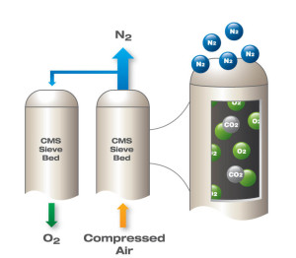

Figure 1. - Gas separation by PSA.

### Materials Specifications

The carbon molecular sieve is a nonpolar adsorbent, which has a different adsorption rate for oxygen and nitrogen. CMS contains small pores of a precise and uniform size that is used as an adsorbent for gases, they can have from 200 to 1200 m2per gram [2]. When the pressure is high enough, oxygen molecules, which pass through the CMS pores much faster than nitrogen molecules , become trapped in the pores; With this , nitrogen molecules remain free in the gas stream, leaving an enriched nitrogen gas phase . The CMS releases oxygen when the system reduces pressure. This empties CMS pores so it can be ready for another cycle of nitrogen enriched air and **oxygen production as a purge.**

CMS appears small, grains similar to black rice 1.0 x 2.0 mm in size and a density of about 650 g / L. Saturation is generally reached about 60 seconds under a pressure of 0.8 MP a (116 psi). CMS comes in different grades and models.

.

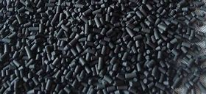

Figure 2.- Molecular Carbon Sieves (CMS)

Activated carbon is an adsorbent material created from charcoal and has a different adsorption rate for oxygen and nitrogen.

This material has a large number of uses, it can be used for spill cleanup, drinking water filtration, air purification, fuel storage for natural gas and hydrogen, etc.

The small stones of the material contain n small pores of an irregular size and without pattern when they are generated in a homemade way. If the pressure is high enough, the nitrogen molecules, which pass through the carbon pores much faster than the oxygen molecules, are trapped inside the pores; then the molecules oxygen remains free within the gas stream, leaving a gas phase oxygen enriched. The activated carbon free nitrogen when the system reduces the pressure. This empties the pores of the material so it is ready for another cycle of production of enriched oxygen and **nitrogen as a purge.**

Although activated carbon with standardized measures and properties exists in commercial products, when they are produced in an artisanal way, these properties and measures would not be guaranteed.

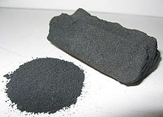

Figure 3. - Activated carbon

Zeolite is a stone composed mainly of aluminum and silicon, it has a structure with micro pores and it stands out for its ability to hydrate and dehydrate in a reversible way. Currently more than 206 types of zeolites have been identified and are usually found in conjunction with sedimentary, volcanic and metamorphic rocks.

They are normally sold as commercial absorbents and are used for oil refining, coloring of liquids and gases, control of contaminants, water purification, etc.

Currently there are artificial zeolites that have been designed for specific purposes and using sol-gel procedures.

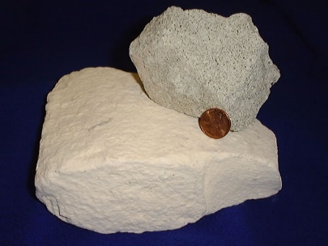

Figure 4. - Zeolite

Sources

1. Chai, S. W.; Kothare, M. V.; Sircar, S. (2011). "Rapid Pressure Swing Adsorption for Reduction of Bed Size Factor of a Medical Oxygen Concentrator". Industrial & Engineering Chemistry Research.
2. <https://www.sciencedirect.com/topics/chemistry/carbon-molecular-sieve>
3. <https://www.sciencedirect.com/topics/agricultural-and-biological-sciences/activated-carbon>
4. <https://www.sciencedirect.com/topics/earth-and-planetary-sciences/zeolite>

## Safety sheets catalog

Catalog of safety sheets in several languages:

<http://alsafetydatasheets.com/>

Oxygen Safety Sheet:

<http://alsafetydatasheets.com/download/dk/Oxygen_compressed-DK_ENG.pdf>



Nitrogen safety sheet:

<http://alsafetydatasheets.com/download/dk/Nitrogen_NOAL_0089A_DK_EN.pdf>



CO 2safety sheet:

<http://alsafetydatasheets.com/download/fi/Carbon_dioxide_NOAL_0018A_FI_EN.pdf>



## Recommendations for the use of oxygen cylinders

Although the oxygen concentrator does not have an oxygen cylinder in its conceptual design, it is more like a possible extension through the use of a compressor and an oxygen tank, the same recommendations should be considered when operating with concentrated oxygen at high pressure.

* Always make sure that oxygen is flowing before placing the administration device over the patient's mouth and nose.
* Do not use oxygen near flames or sparks. Oxygen intensifies the flames. Do not smoke or allow anyone else to smoke around oxygen in transport, in use, or on standby.
* Do not use grease, oil, or petroleum products to lubricate or clean the pressure regulator or any connecting hose, etc. This could cause an explosion.
* Do not place the oxygen cylinders in an upright position unless they are well secured.
* If the cylinder falls, the regulator or valve could be damaged or cause injury.
* Do not attach the valve caps or protectors when moving or lifting the cylinders.
* Do not deface, alter, or remove any labels or markings on the oxygen cylinder.
* Do not try to mix gases in an oxygen cylinder or transfer oxygen from one cylinder to another.
* Never use oxygen without a secure regulator that is properly adjusted.
* When the tank is not in use, keep the valves closed even if the tank is empty. Store the oxygen tanks below 125°F.
* If you are defibrillating, make sure that no one touches or is in contact with the victim or the resuscitation team.
* Do not De-fibrate someone near flammable materials, such as free-flowing gasoline or oxygen.
* Never drag or roll the cylinders.
* When you must move a cylinder, always hold the cylinder with both hands and never by the valve or regulator.
* Do not store oxygen cylinders near flammable or water heaters, near electrical or telephone booths, where anything heavy may fall on them, where they may tip over or be exposed to heat or direct sunlight.
* When transporting oxygen bottles: do not store them in the trunk; secure them in the event of a sudden stop, acceleration, or sharp turn, when they can become a serious projectile hazard; remove them immediately from the vehicle instead of risking exposure to heat, which could cause a potentially dangerous gas release.

Source:

<https://marydonahue.org/oxygen-administration-quick-facts>

## Linear mechanical modeling during respiration

Objective: Obtain a transfer function that can be used in a controller for the non-invasive respirator.

Figure 1. - Diagram of the mechanical model of breathing to the lungs.

We first need a descriptive linear model of the mechanics of a lung. Air channels are divided into two categories:

Long or central (bronchi- central alveolus). $R_{C}$

Small or peripheral (alveolus). $R_{P}$

When air enters the alveolus, there is an expansion of the chest cavity by almost the same volume. This is represented by the connection $C_{L}$ and $C_{W}$ in series. However, a small fraction of the volume of air entering the respiratory system is diverted from the alveolus as a result of the expansion of the central airways and the compressibility of the gas. The deviated volume is very small under normal conditions, however, as there is a disease, obstructions can occur that increase resistance $R_{P}$, that is, an increase in stiffness of the lung or pectoral expansion, that is, decrease $C_{L}$ and / or $C_{W}$. To take these effects into account, we consider a deviation conformity called Cs in parallel to $C_{L}$ and $C_{W}$.

Where: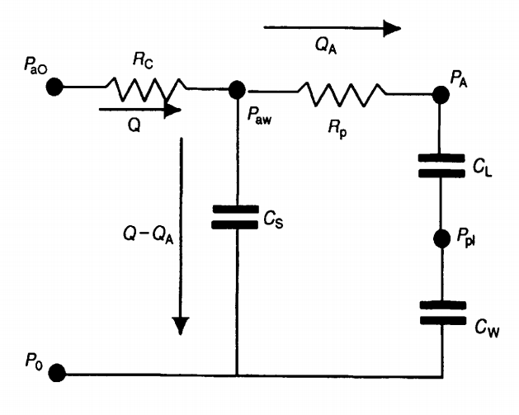

$PaO$ = Inlet air pressure [=] ${cmH}_{2}O$

$P_{aw}$ = Central air pressure [=] ${cmH}_{2}O$

$P_{A}$ = Alveolus pressure [=] ${cmH}_{2}O$

$P_{pl}$ = Pleural space pressure [=] ${cmH}_{2}O$

$P_{0}$ = Ambient pressure [=] ${cmH}_{2}O$

Cs = Diversion conformity [=] $\frac{L}{{cmH}_{2}O}$

$C_{L}$ = Partial fraction of the lung [=] $\frac{L}{{cmH}_{2}O}$

$C_{W}$ = Pectoral expansion [=] $\frac{L}{{cmH}_{2}O}$

$R_{C}$ = Central / long flow resistance [=] $\frac{{cmH}_{2}O}{L}$

$R_{P}$ = Peripheral / small flow resistance [=] $\frac{{cmH}_{2}O}{L}$

Q = Air flow [=] $\frac{L}{min}$

$Q_{A}$ = Flow delivered to the alveolus [=] $\frac{L}{min}$

Using Kirchhoff's second law (applied to the node $P_{aw}$ ), if the flow delivered to the socket is $Q_{A}$ , then the outflow from the socket is defined as $Q$  - $Q_{A}$. Applying KCL to the closed loop system containing: Cs, $R_{P}$, $C_{L}$ and $C_{W}$ then we have:

$$R_{P}Q_{A}+ \left(\frac{1}{C_{L}}+\frac{1}{C_{W}}\right)\int{Q_{A}}dt= \frac{1}{C_{S}}\int{\left(Q- Q_{A}\right)dt} Eq. 1$$

Applying Kirchhoff's first law to the containing circuit $R_{C}$  and Cs, then we have:

$$P_{ao}= R_{C}Q+ \frac{1}{C_{S}}\int{\left(Q- Q_{A}\right) dt} Eq. 2$$

Making the differential equation with Eq. 1 and Eq. 2 with respect to time and reducing the two equations in one eliminating the $Q_{A}$  we obtain an equation that relates $P_{ao}$  to Q:

$$\frac{d^{2}P_{ao}}{{dt}^{2}}+ \frac{1}{R_{P}C_{T}}\frac{{dP}_{ao}}{dt}= R_{C}\frac{d^{2}Q}{{dt}^{2}}+\left(\frac{1}{C_{S}}+\frac{R_{C}}{R_{P}C_{T}}\right)\frac{dQ}{dt}+\frac{1}{R_{P}C_{S}}\left(\frac{1}{C_{L}}+\frac{1}{C_{W}}\right)Q Eq. 3$$

Where $C_{T}$ can be defined as:

$$C_{T}= {\left(\frac{1}{C_{L}}+\frac{1}{C_{W}}+\frac{1}{C_{S}}\right)}^{-1} Eq. 4$$

Using LaPlace transform.

$$L\left\{\frac{d^{2}P_{ao}}{{dt}^{2}}+ \frac{1}{R_{P}C_{T}}\frac{{dP}_{ao}}{dt}= R_{C}\frac{d^{2}Q}{{dt}^{2}}+\left(\frac{1}{C_{S}}+\frac{R_{C}}{R_{P}C_{T}}\right)\frac{dQ}{dt}+\frac{1}{R_{P}C_{S}}\left(\frac{1}{C_{L}}+\frac{1}{C_{W}}\right)Q\right\} Eq. 3$$

This equals:

$s^{2}P_{ao}\left(s\right)-sP_{ao}\left(0\right)-P_{ao}\left(0\right)+\frac{1}{R_{P}C_{T}}\left(sP_{ao}\left(s\right)-P_{ao}\left(0\right)\right)= R_{C}\left(s^{2}Q\left(s\right)-sQ\left(0\right)-Q\left(0\right)\right)+\left(\frac{1}{C_{S}}+\frac{R_{C}}{R_{P}C_{T}}\right)\left(sQ\left(s\right)-Q\left(0\right)\right)+\frac{1}{R_{P}C_{S}}\left(\frac{1}{C_{L}}+\frac{1}{C_{W}}\right)(Q\left(s\right))$ Ec. 4

Substituting time 0; $P_{ao}\left(0\right)=0$ and $Q\left(0\right)=0$, and taking the common factor on both sides:

$$P_{ao}\left(s\right)\left(s^{2}+\frac{s}{R_{P}C_{T}}\right)= Q\left(s\right)\left\{R_{C}s^{2}+\left(\frac{1}{C_{S}}+\frac{R_{C}}{R_{P}C_{T}}\right)s+\frac{1}{R_{P}C_{S}}\left(\frac{1}{C_{L}}+\frac{1}{C_{W}}\right)\right\} Eq. 5$$

With all of the above considerations we obtained a transfer function with the following characteristics:

$$\frac{Q(s)}{P_{ao}(s)}= \frac{\left(s^{2}+\frac{s}{R_{P}C_{T}}\right)}{\left\{R_{C}s^{2}+\left(\frac{1}{C_{S}}+\frac{R_{C}}{R_{P}C_{T}}\right)s+\frac{1}{R_{P}C_{S}}\left(\frac{1}{C_{L}}+\frac{1}{C_{W}}\right)\right\}} Eq. 6$$

Considering the pulmonary factors presented on page 31 and substituting the equation Eq. 4 in the equation Eq. 6, we can calculate:

Cs = 0.005 $\frac{L}{{cmH}_{2}O}$

$C_{L}$ = 0.2 $\frac{L}{{cmH}_{2}O}$

$C_{W}$ = 0.2 $\frac{L}{{cmH}_{2}O}$

$R_{C}$ = 1 $\frac{{cmH}_{2}O}{L}$

$R_{P}$ = 0.5 $\frac{{cmH}_{2}O}{L}$

$$\frac{Q(s)}{P_{ao}(s)}= \frac{\left(s^{2}+420s\right)}{\left\{s^{2}+620s+4000\right\}} Eq. 6.1$$

So, we already have a control function that would regulate the operation of the valve based on oxygen pressure and volumetric flow to the patient. However, it is also necessary to take into account the golden rule of inhalation-expiration which tells us that for each second of inhalation, it must be two seconds of expiration. So we need to include a feedback in the form of negative pressure that regulates the action time inside the procedure programming but not directly to the control system.

For our controller in real life we ​​will use the transfer function shown in the equation Eq. 6.1, however, their coefficients in the denominator and numerator can be adapted as appropriate using equation Eq. 6.

If you model the process of the artificial respirator in “Altair Activate” © you will see that the transfer function allows a flow of a sine type, which is the most similar to natural respiration. For more information see annex A table 4.

Up to this point the model can control partial respiration in mild to moderate cases.

As a future second part, we are considering more severe cases with total respiration which requires taking into account:

* The gas exchange of CO2, H2O, O2 and other gases during respiration.

Chemoreceptors are required to measure CO2concentrations, a lower neuron circuit in the brain to measure respiratory rate, and the strength of the muscles of the respiratory system.

* Extract H2O vapor generated during respiration and expelled during exhalation pipe to prevent condensation water and fill the lungs if it reaches the steam dew point.
* The maximum pressure that the alveolus can bear (maximum $P_{A}$).

Although we can model and explain the solution for each of the cases, we lack the budget, parts and time outside working hours in order to do all the physical and medical tests that are needed in real time, so we have to work with a slowdown pace.

Source:

Michael C.K. Khoo. Physiological Control Systems: Analysis, Simulation, and Estimation, segunda edición. The Institute of Electrical and Electronics Engineers, Inc. Publicado en 2018 por John Wiley & Sons, Inc. pp 31-61.

## Multimedia







